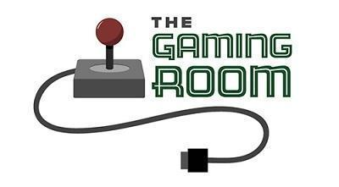

Draw It or Lose It

CS 230 Project Software Design Template
Version 1.0

Table of Contents

CS 230 Project Software Design Template 1
Table of Contents 2
Document Revision History 2
Executive Summary 3
Requirements 3
Design Constraints 3
System Architecture View 3
Domain Model 3
Evaluation 4
Recommendations 5

Document Revision History

Version | Date | Author | Comments
1.0 | 03.19.26 | Christopher Sciarratta | Writing info for the software designing project
1.1 | 04.02.26 | Christopher Sciarratta | Updating developing methods for all application systems.
1.2 | 04.15.26 | Christopher Sciarratta | Updating recommendation section for all software devices.

Instructions
Fill in all bracketed information on page one (the cover page), in the Document Revision History table, and below each header. Under each header, remove the bracketed prompt and write your own paragraph response covering the indicated information.

Executive Summary

In the Gaming Room, the employees are tasked to create a web-based game, based on the client’s requirements, that is currently shown only on an android application. They have officially named their designed application, “Draw It, or Lose It,” and the client is hoping for it to be playable across all other devices, besides android. Lastly, the inspiration of the web-based game should be based on an 80’s television game show titled “Win, Lose, or Draw.”

Design Constraints

The employees in the Gaming Room have acquired a deployment for the Draw it, or Lose it game needed for the android applications. For this, the CTS has asked them to expand this web-based game to the website, with the tech stack also needed to be compatible with its level of deployment. The CTS has selected the code-language application, Java, for this job. Java has to be used to keep the tech stack in good working order with the new deployment system. APIs that are found within the android application systems also have to be examined and tested for the game to be functioning well for mobile devices.

System Architecture View

Please note: There is nothing required here for these projects, but this section serves as a reminder that describing the system and subsystem architecture present in the application, including physical components or tiers, may be required for other projects. A logical topology of the communication and storage aspects is also necessary to understand the overall architecture and should be provided.

Domain Model

The Entity class contains a main driver class that will be used to initiate the designing of the Team, Game, and Player class. These three classes inherit the functions and quality of the Entity class. All four of the aforesaid classes, the Player, Team, Game, and Entity class, have to reference each other. In order to approach the desires or explanations that the client has pointed out, the project has to be designed or created using the ProgramDriver class. Using the ProgramDriver allows us to view each of the classes being created and then executing them in the project. Then there is the SingletonTester class, which helps run the project for each class based on the given limitations of the application. For this, there will be more than one player or team for this game while also allowing a game session to be launched in unison with the selection.
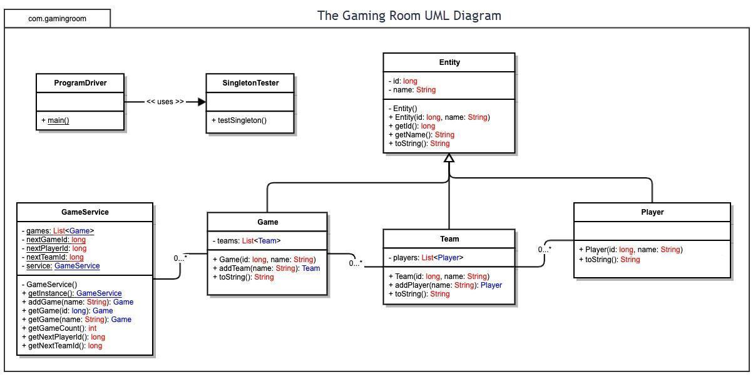

Evaluation

04/02/2026
In the Evaluation table below, I was able to update the following information based on the details recommended for further findings. Based on the gathered input that I was able to finish in the project, much of the game was able to run efficiently on Eclipse, one of the most well known programming language models that developers use, which I used for testing by updating the JAVA files. I was also able to collect information about the benefits and drawbacks of each application including the type of server and the type of network they support as well as the cost of acquiring them.

Development Requirements | Mac | Linux | Windows | Mobile Devices
Server Side | In order to buy a server and then run it through IOS, it has to be purchased for only $20, which, when purchased correctly, the server will become useful for designing websites, which might include things like the macOS Server, which can allow you to get in touch with the server, which makes it useful to operate on devices that support it. The downsides are the cost limitations for options compared to other applications. | Although the license for Linux is free, the cost depends on what is being required for the server and what has to function properly for it to work. However, there are not as many people that seem to be aware of how to use the Linux application, likely due to the drawbacks being involved, which include problems with the compatibility of file formatting. | For Windows, you are able to use its server based on the type of server that you are willing to require. You also have to purchase a Windows license, with the price of them being around $6,200 to $500 per installment for each year. This makes Windows more expensive. The drawbacks are that Windows security seems very lacking in it being vulnerable to malware and other issues within the software. | In modern technology, the cost of mobile device servers can vary, depending on the structure, storage, or CPU that application can hold. However, they also help with managing the costs of each server if these applications have normal traffic found within the app you are using. The drawbacks are that the hosting platforms are stored in a cloud, which leaves organizations more exposed to hackers and cyber attackers who interfere with the program software.
Client Side | In order for Mac computers to run developing programs, users might use the most recent version of XCode if it is featured on an Apple device. Also, fewer people in this country use the MacOS software for programming since most people, including me, prefer using Windows. | Using Linux for development should work properly since using different language-applications, like Java or C++, would be acceptable. The support of allowing multi-users would be found directly on Linux supported software. Linux’s security features are more open-sourced compared to other software. | Windows is commonly used with programming languages like C#, which would provide no existing limitation to enter an application issued by the client. This type of server is used by most computer users in the country for developing assignments. | Although many mobile devices do not support multi-user strategies, they provide multiple developing tools necessary for users to design client projects. Since Android SDK uses Java for developing code, it can be very useful for other software to design specific applications.
Development Tools | SWIFT and Objective-C are the most common programming language tools that people use on Mac. But the most commonly used IDE for Mac is XCode, which can be purchased at a price of $99 per user. Xcode is a type of service made for Apple developers which allows users to test and design different kinds of apps more efficiently and faster. | In order for developing to be useful for Linux, special language tools like Java and Python can be useful, with Python being a free language tool. Eclipse is an IDE that is available on all Linux servers, more than C++. Eclipse offers a wider range of development tools for users to acquire for debugging and managing projects and running language tools to test code to see if it runs efficiently. | On most Windows servers, programmers use C# and .NET for most developing projects. Another recommended IDE called Visual Studio, developed by Microsoft, supports a wide range of different integration tools like TestComplete, which allow users to become familiar with designing lines of code for developing classes for school or elsewhere online. | On most mobile devices, the IDE Android SDK is the most commonly used type used by programmers as a developing tool, which is found at Android Studio. Other types of developing tools, like SWIFT and Objective-C, are also used on mobile devices, along with other coding IDE’s like Python or C++. Eclipse is one of the most popular types of developing application IDEs and one of those applications that I use for developing apps.

Recommendations

Analyze the characteristics of and techniques specific to various systems architectures and make a recommendation to The Gaming Room. Specifically, address the following:

- Operating Platform: For expanding the web-based game, I would recommend using the operating system, Windows OS, for this part of the job. Windows OS would work best for this application since it is a web-based game, and it could be used for troubleshooting issues within the system, or acquiring user requests. Plus, there is a bit more flexibility found within the application when using Windows OS, although there are certain costs to become more aware of when selecting.

- Operating Systems Architectures: The Windows OS that I use during my spare time contains a GUI, which allows for spiffy navigation and tracking across my system. It is also beneficial for me because it contains a number of different types of IDE’s that I can use to create and run applications being handed down for me to fix. For my computer, some of those IDE’s that I have been using before are Visual Studio and Eclipse, along with other ones that I use for completing certain projects that I am assigned.

- Storage Management: Some of the ways on how Windows OS manages its storage include managing it through careful configuration which allows users to look through the application’s settings. Although purchasing a Windows cloud server can become an expensive process to work with, this would serve as a proper investment I could use because the storage could be expanded if the client has any requirements needed to expand the web-based game for more updates or other features.

- Memory Management: There are only two options on the Windows OS application to manage memory, which are physical and virtual memory. Out of the two types of memory management, virtual memory seems to work best for this application since it allows other programs to be controlled more properly. Compared to physical memory, one of the reasons that virtual memory works best for Windows OS is that it allows memory to be protected and lets physical memory be expanded out within the system.

- Distributed Systems and Networks: When using Windows OS for the application, there may be certain problems or issues that we might happen to stumble into when working on it. These types of problems might include issues involving frequent queuing or having the servers be overloaded, which may lead to certain tasks not functioning properly. It is possible that these types of difficulties can be resolved by having members discuss them with the developing team and coming up with strategies on how to fix them.

- Security: Windows OS has multiple ways of staying safe by using security features and functions. One of the many features it has is Windows Defender antivirus, which allows us to block unwanted websites or ads that might interfere or damage the application’s software. My family also uses VPN, which also blocks digital threats that might damage our software. I would also allow my software to scan my hardware daily to make sure it is safe and has no threats interfering with the system, as well as making sure the employees who worked on this system carefully built it to make sure it is protected and safe from threatening issues.

